CERTIFICATION
Permission is granted by the American Kennel Club
for the holding of this event under the
American Kennel Club rules and regulations.
Gina DiNardo, Secretary

ENTRY METHOD: FIRST RECEIVED
ENTRIES WILL OPEN ON 1 Oct 2020, 08:00 am MST at the Trial Secretary’s address. All entries received before this date will be returned. Overnight or certified mail must be sent with the “No Signature Required” waiver signed.
ENTRIES for Scent Work Trials CLOSE ON 24 Oct 2020, 5:00 pm MST after which time entries cannot be accepted, cancelled, altered, or substituted except as provided for in Chapter 11, Section 6 of the Rules Applying to Dog Shows. Envelopes/transactions containing entries for more than the ten (10) dog maximum and/or entries received prior to the opening date shall be treated as an invalid entry and shall be returned to the sender.
READ THE COVID-19 EVENT PLAN PROVIDED IN THIS PREMIUM. SUBMITTAL OF AN ENTRY TO THIS TRIAL INDICATES FULL COMPLIANCE WITH THE RULES AND REGULATIONS GOVERNING THIS EVENT, INCLUDING ALL COVID-19 RELATED PRECAUTIONS AND WAIVERS.

PREMIUM LIST

Great Falls Dog Training Club
Licensed by the American Kennel Club
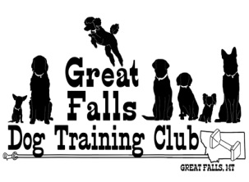
All Novice Elements, & Handler Discrimination
Scent Work Event 31 Oct 2020 A.M. – 2020214122
Scent Work Event 31 Oct 2020 P.M. – 2020214123

Nicholson Ranch
57 Comer Hill Rd, Great Falls, MT 59404

Scent Work Trial ENTRY LIMITS: 60 entries
(No Wait List Offered)
To be held Indoors/Outdoors
Trial Hours:
Scent Work Event - Check-in from 8:00-8:45 am
Handler’s Briefing at 8:45 am, first dog to follow at 9:00 am

Entry Fees
*an entry is defined as a single run by a single dog, in a single class. Entry fees include a $3.50 per run AKC recording fee.

Scent Work First entry ………………………………….……..……………….....$20.00 Additional entries of same dog same trial………….……….…………….……...$15.00

Officers of the Great Falls Dog Training CLUB

President ……………………………………………………………………...Barbara Flaherty
Vice President ……………………………………………………………………..Shaun Opp
Secretary………………………..…Linde Dauner, PO. Box 2712, Great Falls, MT. 59404
Treasurer………………………………………………………………………….…Joanie Carl
Board of Directors……………....Sandy Schumacher, Sheila Eastman, Carol Grasseschi

Emergency Services
Fire/ Ambulance/Police- Cascade County
911
Benefis Health System – Emergency Room 1101 26th St South, Great Falls, MT . (~8.3 miles away)..

Veterinarian on Call: Best Friends Animal Hospital
1520 9th St S., Great Falls, MT (406) 453-2200
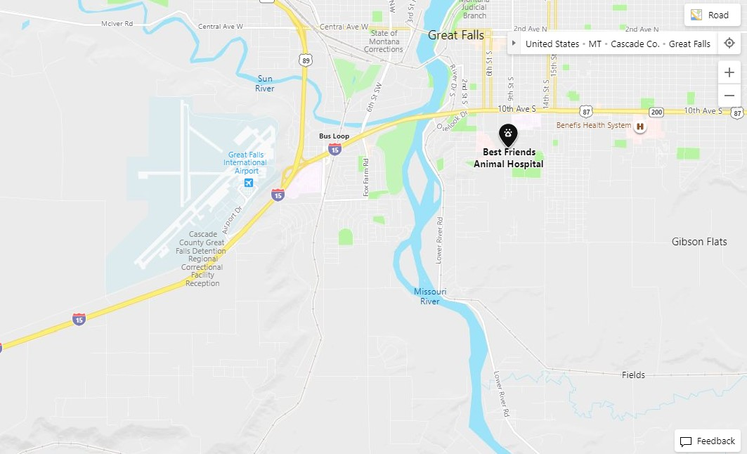

OVERNIGHT PARKING Information
***There is no overnight parking at the trial site***
Dick’s RV Park ..............................1403 17th St SW, Great Falls, MT 59404 (406) 452-0333 KOA Campground ..........................1500 51ST St S., Great Falls, MT 59404 (800)562-6584

Hotel Information

Mid-Town Motel Perkins Rest. 526 - 2 Ave North, Great Falls ……….. (406) 453-2411
Comfort Inn 1801 Marketplace Dr, Great Falls ……………………... (877) 424-6423
Budget Inn 10th Ave South & Fox Farm Rd, Great Falls ………………. (406) 453-1602
Staybridge Suites 201 3rd St NW, Great Falls …………………………. (877) 859-5095
Super 8 Motel 1214 13th St S, Great Falls ………………………….. (406) 727-7600
Days Inn 101 - 14th Ave Northwest, Great Falls …………………………….(866) 539-0036
Quality Inn 220 Central Ave, Great Falls……………………………………… (406) 761-3410
Holiday Inn 1100 5th St So, Great Falls, MT …………………………………… (855) 516-1092

Directions to the Trial Site

The Nicholson Ranch, 57 Comer Hill Road, Great Falls, MT

Directions from the North: Take I-15 South, take Exit 277 (Great Falls International Airport Exit). Turn left at intersection, Head south toward the Truckstops. Take the first right before the truckstop (Tri Hill Frontage Rd). Drive 2.6 miles. Turn left onto Comer Hill Rd. Drive ½ mile. The Nicholson Ranch will be 2nd house on your left.

Directions from the South: Take I-15 North Exit 277 ( Great Falls International Airport Exit). Turn right at intersection. Head south toward the Truckstops. Take the first right, before the truckstops (Tri Hill Frontage Rd). Drive 2.6 miles. Turn left onto Comer Hill Rd. Drive ½ miles. The Nicholson Ranch will be 2nd house on your left.

MAP

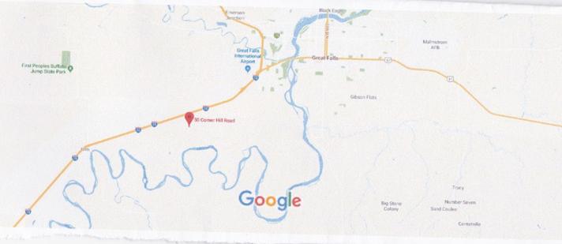

Scent Work Trial Chairperson | Scent Work Trial Secretary
Joyce K. Hoyt  3800 Stagecoach Ave, Great Falls, MT 59404  Email: hoytj@q.com  (406)868-3848 | Lori A. Eby  4000 62nd Ave SW, Great Falls, MT 59404  Email: forestlori@hotmail.com  (406) 868-2063

Scent Work Event Committee
Joyce K. Hoyt, Lori A. Eby, Jeanne Stehno, Jan Connor, and Charmaine Nicholson
Stewards/Volunteers – Jeanne Stehno, Debbie English
Trophies – Joanie Carl

Entry Fees
*an entry is defined as a single run by a single dog, in a single class. Entry fees include a $3.50 per run AKC recording fee.

Scent Work First entry ………………………………….……..……………….....$20.00 Additional entries of same dog same trial………….……….…………….……...$15.00
“ Multiple dogs from the same owner may be entered in the same class, provided they are run by different handlers."

sCENT wORK Event Judge and Assignments
Mary Lehman, #102843 ………………………….………………Helena, MT

SW Novice | Saturday AM | Saturday PM
Container | Mary Lehman | Mary Lehman
Interior | Mary Lehman | Mary Lehman
Exterior | Mary Lehman | Mary Lehman
Buried | Mary Lehman | Mary Lehman
Handler Discrimination | Mary Lehman | Mary Lehman
SCENT work Elements Offered & judging times
SATURDAY AM/PM
Judging begins at 9:00 am
Container Novice A/B
Interior Novice A/B
Exterior Novice A/B
Buried Novice A/B
Handler Discrimination Division Novice A/B

HANDLER DISCRIMINATION DIVISiON
Handler Discrimination classes are titling classes in which the targeted scent is that of the handler themselves. Handlers are required to provide their own scented articles in a plastic bag, for the Novice class, one cotton glove or cotton sock, for Advanced, Excellent, and Master, cotton balls or cotton swabs. Three qualifying scores are required to earn titles in each class.
Handlers may utilize any method they feel is best to scent their article. Suggestions include rubbing the article on the handler’s body or storing the item in dirty laundry.
Dog Eligible to Enter
The Scent trial is open to all dogs SIX (6) months of age or older. Dogs must be registered with the American Kennel Club or have AKC Limited Registration, Purebred Alternative Listing/Indefinite Listing Privileges (PAL/ILP), an AKC Canine Partners listing number or approved Foundation Stock Service (FSS) breeds are eligible to participate.
Dogs with a Purebred Alternative Listing/Indefinite Listing Privileges (PAL/ILP) or an AKC Canine Partners listing number must be spayed or neutered in order to compete.
Condition of the Dog. Dogs with physical challenges (including amputees) are eligible to participate provided that, in the opinion of the judge, they display no signs of physical discomfort and can safely complete the search. Dogs with bandages, sutures, or visible wounds are not eligible. Deaf dogs and blind dogs are allowed to enter. Dogs that are both deaf and blind are able to participate so long as the handler is in control of the dog at all times, the dog can complete the requirements of the class, and the dog does not appear to be under undue stress in the opinion of the judge.
Handling More Than One Dog. Handlers may not handle more than one dog in each class (with the exception of Handler Discrimination classes). Multiple dogs from the same owner may be entered in the same class, provided they are run by different handlers."
Mail Scent Work entry forms and fees to:

Trial Secretary: Lori A. Eby
4000 62nd Ave SW,
Great Falls, MT 59404

Please make checks payable to the Great Falls Dog Training Club
No entries will be accepted by phone, email, fax, or hand delivery. Express mail entries must include the signature waiver allowing them to be left at the secretary’s address. Inquiries may be directed to Lori Eby at forestlori@hotmail.com. No entry shall be made and no entry shall be accepted which specifies any conditions as to its acceptance.
Illegible entries will not be processed and will be returned to the exhibitor. Returned checks do not constitute a valid entry and the Trial Secretary will add a $25.00 collection fee to the amount of each returned check.

STAGING AREA, HANDLER’S BRieFING, AND WARM-UP INFORMATION
Staging Area will be out of view of search area(s). Staging area will include crating, warm-up and waiting area, as well as the secretary table for check-ins and posting of running order and results.
The Handler’s Briefing will take place in view of the search area prior to the start of each class, after the hide(s) have been set and after the Demo Dog has run. In the Handler’s Briefing the judge will explain if there’s an off-leash option, number of hides, maximum height of hides and maximum time for the search. NO DOGS are to be present during the Handler’s Briefing.
Warm-Up Area One labelled container per target odor being used in the trial on that day will be placed in the warm-up area. This will allow handler-dog teams to prepare themselves for the search prior to their run. Each team should limit their warm-up to two minutes or less so that others may be able to use the warm-up area as well. Clubs may also place blank containers in the warm-up area if they choose.
There may be livestock (horses) on the premises but they will not be in any search areas and they will be behind enclosures.

Search Area and Ring Conditions
Search areas may be of any shape, and of the size specified in the Regulations for each class.
Search Area Conditions. Searches may be indoors, on matted, packed earth, carpeted, or tiled surfaces, or outdoors on grass, gravel, earth, concrete, or asphalt surfaces.
Search Area Sizes will be as follows, Container Novice (250-400sqft.), Container Advanced (400-600sqft.) Interior Novice (100-200sqft.), Interior Advanced (200-400sqft.), Exterior Novice (200-400sqft.), Exterior Advanced (400-800sqft.) Buried Novice and Advanced (150-200sqft.) Handler Discrimination Novice (250-400sqft.).
Additional Site Information
Trial Site. It is not appropriate to scout the trial location prior to the trial date. Many search locations are real-life environments and such visits may risk the host losing the opportunity to use the location in the future.
Chapter 5, Section 35. Possession of Odors and Training. No person other than those engaged in the administration of the trial shall be in possession of any of the target odors when on the trial grounds. There shall be no training on the grounds of the AKC Scent Work trial, other than in the designated warm-up area.
Spectator Area. Spectators must comply with the COVID-19 Event Plan outlined in this premium.
Indoor Crating space may be available. The Great Falls Dog Training Club and the Nicholson Ranch will not be responsible for any lost or damaged items left at the show site.
Exhibitors are responsible for cleaning up after their dog(s). Any exhibitor failing to do so may be excused without benefit of refund if the Event Committee deems the exhibitor to be in violation of this requirement. There will be an outside designated area where dogs are allowed to relieve themselves. Cleaning supplies and disposal sites will be available at various locations around the show grounds.

Scent Work event Ribbons and trophies
Placement ribbons will be awarded in each element as follows:
First Place……………………………………...………...………………….……….……...Blue
Second Place……………...……………………..……………………………………….....Red
Third Place……………………………..…………………………………...……….........Yellow
Fourth Place……………………………………...…………………………..……….…...White
Qualifying Score……………………………………………….…………...…..…..Dark Green High in Trial (for 4 same difficulty level elements, excluding Handler Discrimination)...................................................................3-Streamer Rosette.
High Combined Division ( Includes same 4 difficulty level elements including Handler Discrimination)....................................................3-Streamer Rosette _______________________________________________________________

TROPHIES
HIGH IN TRIAL................................................... Embellished Chair/Throw
High Combined Division ........................................Cash Prize $30
1st Place in each Class................................... Dog Related Prize
2nd – 4th Place in each Class .................................Dog Related Item
New Title Rosette will be awarded to all dog and handler teams finishing
an Element or Level Title.

All exhibitors should obtain a copy of the Regulations for Scent Work, by downloading them here: http://images.akc.org/pdf/rulebooks/RSW001.pdf

NOTICE TO EXHIBITORS

SAFETY, BEHAVIOR and LIABILITY
The safety of the dog is our primary concern. By entering this trial, exhibitors acknowledge that they are familiar with the rules and regulations of this sport, and that their dogs are familiar with and able to perform all searches safely. It is expressly understood that exhibitors alone are responsible for the behavior of their dogs and/or children. Any exhibitor whose dogs and/or children create an unnecessary disturbance or repeatedly engage in unsafe or disruptive behavior may, at the discretion of the trial committee, be asked to leave the show site. In such case, no refund of any fees paid will be made. The Great Falls Dog Training Club and its agents, employees, etc., will assume no responsibilities for any loss, damage or injury sustained by exhibitors or handlers, or to any of their dogs or property and further assumes no responsibility for injury to children. The Great Falls Dog Training Club reserves the right to decline entries for cause and may remove any dog on account of aggression. No one shall have any recourse or claim against the Great Falls Dog Training Club or any official thereof.
Collars, Leashes and Harnesses. During searches, dogs must wear a properly fitted collar or harness approved by the judge. A wearable camera such as a Go Pro may be mounted to the dog’s harness, if desired. Leashes may be of any length and/or retractable. The leash should be made of plain, pliable material.
All dogs must be on leash at all times, and retractable leashes may not be used when on trial grounds (except during judged searches). Dogs must enter and exit the search area with the leash attached to the collar or harness, including when waiting in the search area before and after the search. An off-leash option may be offered at the discretion of the judge, only if the area is completely enclosed.
REFUNDS
No entry fee will be refunded if the trial cannot open or be completed by reason of riots, civil disturbances, fire, an act of God, public emergency, act of a public enemy, or any other cause beyond the control of the organizing committee. No entry fee will be refunded in the event a dog is absent, disqualified, excused, or barred from competition by the action of the Trial Committee. Dogs pulled after closing because of injury or other medical condition are not eligible for a refund.
Bitches in season will be refunded the full entry fee. Notification in writing must be given to the trial secretary no later than one half hour prior to the start of the first class of the day of the trial.

RINGSIDE
Judges are not required to wait for dogs. The Owner of each dog is solely responsible for having it ready at the search area when it is to be judged. The Club has no responsibility to provide service through a public address system or stewards or runners for the purpose of calling or locating dogs that are not brought into the ring when required.
EXHIBITOR CHECK-IN: At check-in you will receive your armband number and Run Order Agenda. Once the time and location for check-in is determined all exhibitors will be notified by email.
Exhibitors MUST check-in EACH day they are entered.
Claims will be arbitrated as set forth on the Official AKC Entry Form for this event.

“Exhibitors should follow their veterinarian’s recommendation to assure their dogs are free of internal and external parasites, any communicable diseases, and have appropriate vaccinations.” Additionally, clubs should include any specific local or state health requirements; for example, proof of rabies vaccination.

***THERE IS NO OVERNIGHT PARKING AVAILABLE AT THE TRIAL SITE***

COVID-19 EVENT PLAN
FIRST OF ALL – if you feel ill prior to or during the trials, PLEASE do not stay/go home!
It is not worth the possibility of infecting others. The following information is considered part of the official premium. By entering the trial, the exhibitor agrees to comply with the requirements and accepts the waiver of liability. Compliance with all COVID-19 requirements is mandatory. Any person(s) not following this COVID-19 Event Plan, including additional requirements either posted or verbally explained at the trial, will be asked to leave, not allowed to continue participation at the trial, and will not receive a refund. COVID-19 requirements are subject to change either prior to or even during the event. Exhibitors are encouraged to check the following websites for the most up-to-date information: • http://www.cchdmt.org/covid19/ • https://covid19.mt.gov/Frequently-Asked-Questions. DAILY SCREENING: Each day BEFORE entering the building, all persons will be asked questions about whether they have been exposed to COVID-19 or have any of the symptoms associated with COVID-19. We may also check your temperature with a noncontact thermometer. If you answer ‘yes’ to any of the questions or have a fever of greater than 100.4 oF, you will NOT be allowed to enter the building. Daily Questions will be: • Within the last 14 days, have you: o Experienced a new cough not attributable to another health condition? o Experienced new shortness of breath not attributable to another health condition? o Experienced a new sort throat not attributable to another health condition? o Experienced new muscle aches not attributable to another health condition or a specific activity? o Experienced an elevated temperature (above your normal range)? o Been in contact with a person who is currently sick with suspected or confirmed COVID-19? By answering the questions and submitting to a temperature check, you affirm the following: I agree to abide by the GFDTC’s COVID-19 requirements at all times while attending this event. Requirements include, but are not limited to, a daily health screen, wearing a CDC-recommended face covering at all times while inside the building, practicing social distancing, washing and sanitizing hands frequently, and following posted signage. The Health Steward will document your responses and temperature (if measured) once per day. FACE COVERINGS: Everyone inside the building, including workers and exhibitors, will be required to wear a mask or similar covering that covers the mouth and nose. Please be aware that this could change. We encourage wearing a mask or some type of face covering during your run if possible; if it is necessary for you to remove it to run, it must be put back on before you leave the ring. You may remove your mask after exiting to the outdoors to give you a chance to catch your breath if needed, then put it back on unless you are not going to be within six feet of any other person. Exhibitors whose setups are in the building will be required to wear a mask while at their setups. We also encourage the wearing of masks outdoors unless you are at your setup or are in an area with no other people nearby. (PLEASE – no sitting and chatting close to other people, with or without wearing a mask – this could be considered a “GATHERING” and we must avoid that!!). ARENA TRAFFIC PATTERNS: There will be designated ENTRANCE and EXIT doors to the building, so that people do not pass by each other when going in and out. There will be one-way traffic inside the arena, including ring entrance/exit and access to the bathrooms and food. SPECTATORS/FAMILY: All spectators must follow the COVID-19 Eve protocols. Family members that are not running dogs should not be in the building. Family members that volunteer to work are OK as they are then considered workers, rather than spectators. CRATING: We encourage exhibitors to set up outdoors. Indoor crating spaces will be separated by aisles and all setups must have at least 6 feet of space between them. SANITATION: In addition to the sanitizer each exhibitor will provide for themselves, hand sanitizer will be provided throughout the arena. Exhibitors may consider wearing disposable or washable gloves
FLEXIBILITY AND PATIENCE:
Measures will be in place to maintain distance between exhibitors and workers and provide sanitary conditions. Procedures for the health screen and mandatory briefing will be included in the trial instruction email after closing. Procedures for check-in, run order tracking, waiting for your run, results posting, title ribbons, celebrations, etc. will:1) be explained during the MANDATORY briefing 2) be subject to change at any time; and 3) remain flexible based on the conditions of the arena and the number of exhibitors present. The Trial Committee appreciates in advance your patience and understanding with these conditions. **************************************************** COVID-19 WAIVER Great Falls Dog Training Club: Scent Trial October 31, 2020 I attest to the best of my knowledge that I do not have COVID-19 at the time of attending this event. I also attest that I have not knowingly been in contact with or exposed to any known carrier of COVID-19 within the past 14 days. I agree that I am attending this Event entirely at my own risk and take full responsibility for my own health and safety during this Event. I will follow all AKC, Great Falls Dog Training Club, City, County, State rules and requirements to reduce any exposure and possibility of contracting or spreading the virus during the Event. I fully submit that the Great Falls Dog Training Club, the American Kennel Club, Kings Arena, and any other persons affiliated with the Event are in no way liable for any present or future COVID-19 exposure incurred at any time by any person, whether in attendance or not, during or after this event. ****************************************************
IF YOU ENTER THE TRIAL, YOU AGREE TO THESE CONDITIONS AND ACCEPT THE WAIVER
Send to:
Trial Secretary
Complete Mailing address
City, ST Zip
AKC OFFICIAL ENTRY FORM

 | Container | Interior | Exterior | Buried | Handler Discrimination
31 Oct 2020  Saturday AM | ◻ Novice A/B | ◻ Novice A/B | ◻ Novice A/B | ◻ Novice A/B | ◻ Novice A/B
Saturday PM | ◻ Novice A/B | ◻ Novice A/B | ◻ Novice A/B | ◻ Novice A/B | ◻ Novice A/B
Check Class and Circle A or B
Entry fees: 1st Entry Fee $20 per class Additional Entries of same dog: $15 each trial
Make checks payable to the Great Falls Dog Training Club
 |  | $ _____________ | Total due
Trial Secretary will add a $25.00 collection fee to the amount of each returned check.
AKC Registered Name |  |  |  |  | Registration Number  ◻ AKC/PAL/ILP/CP ◻ Foreign
Call name | Date of birth |  |  | Sex
Breed |  |  |  | Variety
Breeder

Sire

Dam

Owner

Owner’s Address

City |  | State |  |  |  | Zip
Telephone | Email
Handler name (if different from owner): |  |  | Junior Handler # (if applicable):
Fields marked in blue are REQUIRED.
Fields marked in gray must be completed if the information is known.
***Be sure to read the Agreement and sign on the reverse. No form will be processed without your signature !
***AKC Rules, Regulations, Policies and Guidelines are available on the American Kennel Club Web site,
www.akc.org

AGREEMENT

I certify that I am the actual owner of the dog, or that I am the duly authorized agent of the actual owner whose name I have entered. In consideration of the acceptance of this entry, I (we) agree to abide by the rules and regulations of The American Kennel Club in effect at the time of this event, and any additional rules and regulations appearing in the premium list of this event and entry form and any decision made in accord with them. I (we) agree that the club holding this event has the right to refuse this entry for cause which the club shall deem sufficient. I (we) certify and represent that the dog entered is not a hazard to persons or other dogs. In consideration of the acceptance of this entry and of the holding of this event and of the opportunity to have the dog judged and to win prizes, ribbons, or trophies, I (we) agree to hold the AKC, the event-giving club, their members, directors, governors, officers, agents, superintendents or event secretary and the owner and/or lessor of the premises and any provider of services that are necessary to hold this event and any employees or volunteers of the aforementioned parties, and any AKC approved judge, judging at this event, harmless from any claim for loss or injury which may be alleged to have been caused directly or indirectly to any person or thing by the act of this dog while in or about the event premises or grounds or near any entrance thereto, and I (we) personally assume all responsibility and liability for any such claim; and I (we) further agree to hold the aforementioned parties harmless from any claim of loss, injury or damage to this dog.

Additionally, I (we) hereby assume the sole responsibility for and agree to indemnify, defend and save the aforementioned parties harmless from any and all loss and expense (including legal fees) by reason of the liability imposed by law upon any of the aforementioned parties for damage because of bodily injuries, including death at any time resulting therefrom, sustained by any person or persons, including myself (ourselves), or on account of damage to property, arising out of or in consequence of my (our) participation in this event, however such, injuries death or property damage may be caused, and whether or not the same may have been caused or may be alleged to have been caused by the negligence of the aforementioned parties or any of their employees, agents, or any other person. I (we) agree that the determination of whether the injury is serious shall be made by the event veterinarian and is binding on me (us). I (WE) AGREE THAT ANY CAUSE OF ACTION, CONTROVERSY OR CLAIM ARISING OUT OF OR RELATED TO THE ENTRY, EXHIBITION OR ATTENDANCE AT THE EVENT BETWEEN THE AKC AND THE EVENT-GIVING CLUB (UNLESS OTHERWISE STATED IN THIS PREMIUM LIST) AND MYSELF (OURSELVES) OR AS TO THE CONSTRUCTION, INTERPRETATION AND EFFECT OF THIS AGREEMENT SHALL BE SETTLED BY ARBITRATION PURSUANT TO THE APPLICABLE RULES OF THE AMERICAN ARBITRATION ASSOCIATION. HOWEVER, PRIOR TO ARBITRATION ALL APPLICABLE AKC BYLAWS, RULES, REGULATIONS, AND PROCEDURES MUST FIRST BE FOLLOWED AS SET FORTH IN THE AKC CHARTER AND BYLAWS, RULES, REGULATIONS, PUBLISHED POLICIES AND GUIDELINES.
INSTRUCTIONS
Only teams who participate in all same level elements offered (Container, Interior, Exterior, Buried,),and qualify in each are eligible to win High in Trial. One High In Trial winner is chosen; there is no separate High In Trial for the Novice A and Novice B sections.
The High in Trial is determined by adding the team’s faults across the 4 elements. If there is a tie based on faults, then the team’s times across the elements will be summed and the faster-finishing team will win.
High Combined Division (includes same 4 difficulty level elements including Handler Discrimination) One High Combined Division in Trial winner is chosen; there is no separate High Combined Division In Trial for the Novice A and Novice B sections.

SIGNATURE of owner or his agent duly authorized to make this entry.
SIGN HERE X:__________________________________________________________________________
Phone #: ___________________________________________________________________
Email: ______________________________________________________________________
In case of Emergency – Name: __________________________________ Phone #: ________________

